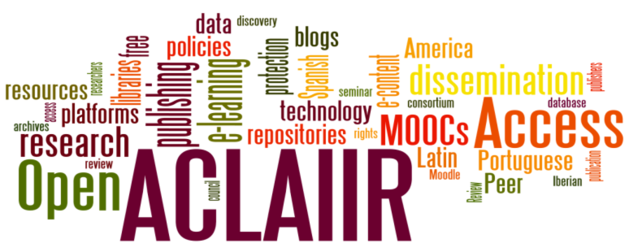


Advisory Council on Latin American & Iberian Information Resources
ACLAIIR AGM & Seminar 2014
Tuesday 17 June, 2014
Milstein Seminar Rooms, Cambridge University Library
West Road, Cambridge CB3 9DR map
10:45 Registration (tea, coffee available)
11:00 Welcome from David Lowe, ‎Head of European Collections, Cambridge University Library
11:15 Annual General Meeting
12:45 Lunch
Seminar: Open Access: the future of academic publication?
Panel I (13:45 – 14:50) OA : Perspectives from the world of publishing
Chair: Joanne Edwards, University of Oxford

- Ellen Collins (OAPEN UK)
- Daniel Pearce (CUP)
- Dr. Rupert Gatti (Open Book Publishers)
Tea (14:50 – 15:05)
Panel II (15:05 – 16:10) OA and its impact on research and teaching
Chair: Aquiles Alencar Brayner, Digital Curator, British Library

- Dr. Martin Eve (University of Lincoln)
- Dr. Ernesto Priego (City University, London)
- Dr. Jenny Bunn (University College, London)
Conclusion (16:10 – 16:20)
The event will be followed by a wine reception.

The cost for the day, including lunch will be £30. The Conference fee (without lunch, but including tea & coffee) will be £10. If you would like to attend please complete the registration form and return by post or e-mail to Emer Stubbs at the University Library, Bristol. There will be no charge for postgraduate students. However, please do complete and return the form.
Speaker Profiles
Panel I (13:45 – 14:50) OA: Perspectives from the world of publishing
Ellen Collins (OAPEN-UK)
OAPEN-UK is a collaborative research project funded by JISC and the AHRC, to gather evidence in order to make informed decisions on the future of open access scholarly monograph publishing in the humanities and social sciences (HSS). Some of the key objectives of the project are to work closely with authors, researchers, publishers and readers to find out their attitudes to and perceptions of open access scholarly monographs, promote awareness of the issues and challenges surrounding OA publishing, and to develop recommendations to aid the discovery of OA scholarly monographs. As well as being a key consultant of the Research Information Network, Ellen has also worked on a wide range of other studies including peer review, the information practices of architects, student usage of academic libraries, open access policies of medical research funders, patterns of behaviour among researchers in different disciplinary groups, and researchers’ use of social media.
Daniel Pearce (CUP)
Daniel is Senior Commissioning Editor for Humanities and Social Sciences journals at Cambridge University Press. CUP provides a range of routes for OA publishing that include both Gold and Green options, as well as developing a suite of wholly open access journals. We look forward to hearing the view from a major academic publisher on the opportunities and challenges of OA publishing.
Dr. Rupert Gatti (Open Book Publishers)
Rupert is a co-founder and the third Director of Open Book Publishers. He is a Fellow of Trinity College, Cambridge, where he is a Director of Studies in Economics. He has held visiting positions at MIT and University of Florence, acted as an Economic Advisor on several EU competition studies, and is on the advisory board of a range of Open Access initiatives and is a frequently invited speaker on the OA movement. Open Book Publishers was founded in 2008 by a small group of academics at the University of Cambridge. Since then, it has grown into an international network of scholars who believe that it is time for academic publishing to become fairer, faster and more accessible.

Panel II (15:05 – 16:10): OA and its impact on research and teaching

Dr. Martin Eve (University of Lincoln)
Martin is a Lecturer in the Faculty of Media Humanities and Performance, University of Lincoln, working on literature and technology. A strong proponent of Open Access, Martin is a member of the steering committee for JISC's OAPEN-UK project and is chief editor of Orbit, the open-access peer-reviewed e-journal on the writings of Thomas Pynchon, as well as being an Academic Project Director for the Open Library of the Humanities. He has written extensively on Open Access, including contributing an article to the British Academy publication Debating Open Access.
Dr. Ernesto Priego (City University, London)
Ernesto is a researcher affiliated to the UCL Centre for Digital Humanities. He co-founded and coordinated the editorial work of The Comics Grid Journal of Comics Scholarship, a pioneering open access academic rapid publication project. He specialises in online publishing for impact and widening participation and in the qualitative analysis of scholarly networks and academic article-level metrics, and has written on the topic of open access in Latin America. Ernesto also serves on various international digital humanities academic committees, including the ad hoc communications committee of the Alliance of Digital Humanities Organizations' (ADHO) and the executive council of the Association for Computers in the Humanities (ACH).
Dr. Jenny Bunn (University College London)
Jenny currently teaches on the UCL archives and records management programmes. Her research interests include the history and ongoing development of the interface between archives and technology and the potential application of cybernetic principles to archival description. After receiving an E-Learning Development Grant, Jenny created DiSARM: Digital Scenarios for Archives and Records Management. Her project aimed to develop a number of digital scenarios to enhance the e-learning opportunities for students on the Department of Information Studies’ (DIS) archives and records management programmes. She has blogged about online learning and the debate around Open Educational Resources.

Advisory Council on Latin American
& Iberian Information Resources
(ACLAIIR)

ACLAIIR AGM & Seminar 2014
Booking Form

Please delete as appropriate:

I should like to attend the ACLAIIR Seminar and AGM (including lunch).
- Please indicate any special dietary requirements.

I should like to attend the ACLAIIR Seminar and AGM. I do not require lunch.

I enclose a cheque for £30 / £10 / I am a postgraduate student.
Cheques should be made payable to ACLAIIR Club

I would like ACLAIIR to invoice my institution.
(Please see the further instructions below**)

Name ....................................................................................

Institution...............................................................................

..............................................................................................

Address ...............................................................................

............................................................................................

e-mail..................................................................................

Please return this form by Monday 9 June to:
Emer Stubbs, Hispanic Studies Librarian
University of Bristol Library
Tyndall Ave
Bristol BS8 1TJ
e-mail: Emer.Stubbs@bristol.ac.uk

**If you would like your institution to be invoiced, please also send the following details to the ACLAIIR Treasurer, Emer Stubbs, at the above address

Addressee for invoice:………………………………………………………………………..
Institution: …………………………………………………………………………………….
Address: ………………………………………………………………………………………
………………………………………………………………………………………………….

Payments can be made by BACS to the ACLAIIR account:
Account name: ACLAIIR Club
Bank: Lloyds TSB
Sort Code: 77-91-12
Account no.: 33453160
BIC: LOYDGB21J14
IBAN: GB65 LOYD 7791 1233 4531 60

